**Leader Overview**



**Volume Overview**

**Be Different**

*Christians have long understood that we live and walk a fine line. We are to be in the world—all things to all people, as Paul put it—yet not of the world. God’s people have always been a chosen people, holy and set apart from the world’s ways. To pull it off, to be truly different, means we must each hold fast to the truth, speaking it when needed, all while humbling ourself and faithfully serving others.*

**Session Overview**

**Humble Yourself**

*In this* **Live** *session, kids will discover Jesus’ teaching that the best way to be first is by putting others first. When we truly follow Jesus, we’re different from the rest of the world. Most people clamor for success, honor, and recognition. But Jesus tells us to mirror God’s heart and honor others above ourself.*

**Bible Lesson**

Party Guests Discover the Best Seat

[Luke 14:1](https://ref.ly/logosref/Bible.Lk14.1), [7–15](https://ref.ly/logosref/Bible.Lk14.7-15)

**Faith Fact**

I will put others first.

**Faith Verse**

[Romans 12:2](https://ref.ly/logosref/Bible.Ro12.2) (NLT)

Don’t copy the behavior and customs of this world, but let God transform you into a new person by changing the way you think.

**Preparing for the Session**

**Leader Preparation Time: 20–25 Minutes**

|  |
| --- |
| ***You Will Need***  ***Large Group***  *• Bible*  *• Worship songs (Song suggestions: “How I Praise” (Lyric Video) by Planetshakers; “I Thank God” (Lyric Video) by Maverick City Music; “Build My Life” (Lyric Video) by Housefires; “Available” (Lyric Video) by Elevation Worship)*  *• For groups not using a phone or tablet only, add:*  *• Projector or TV*  *• Laptop*  ***• Faith Fact Slide***  *•* ***Faith Verse Video*** *or* ***Slide***  *•* ***Bible Lesson Video***  *•* ***Teaching Point Slides 1–3***  *• Lunch box*  *• Variety of wrapped snacks to share with the group*  ***Small Group***  *• Chairs, one per kid*  *• Smartphone, computer, radio, etc. for playing music*  *• Bibles for kids in the group to share*  *• Sticky notes, one sheet per kid*  *• Pencils or pens, one per kid*  *• Ball*  *• Optional: Smartphone to time activity*  *•* ***Small Group Activity Page****, one per kid*  *• Pencils or pens, one per kid*  *• Crayons or markers*  *To access session content and videos from a computer, visit:* [*BibleEngagementProject.com/downloads*](https://bibleengagementproject.com/downloads) |
| ***Getting Ready***  ***Large Group***  *• Download videos and slides if needed.*  *• Select worship song(s) and have them ready to play.*  *• Read the Bible Lesson Scripture to prepare for Teaching Time.*  *• Fill the lunch box with the wrapped snacks.*  ***Small Group***  *• Put the chairs in a circle.*  *• Print copies of the* ***Small Group Activity Page****, one per kid.*  ***First time leading* Live *for Kids? Check out the*** [**Facilitator Guide**](https://0b769b0ed3569ef9d18b-f88d8272f61086866d50d048b43ef630.ssl.cf2.rackcdn.com/sites/biblengagementproject/Listen_Facilitator_Guide.pdf)**.** |

**Large Group**

**30 Minutes**

*See what’s needed at the beginning of the session.*

**Introduction**

Hello, everyone. Today is going to be amazing! I’m so glad you’re here with me to be part of it. We’re going to learn how Jesus wants each of us to be different. What’s one way you’re different from the person next to you? *(Allow responses.)*

There are many ways we’re different from each other. Today we’re going to discover one big way Jesus tells us to be different from the world. But first I have a question. What sounds more fun to you—a birthday party for you or a birthday party for someone else? If you think a party for you sounds more fun, raise your hand. *(Group response)* If you think a party for someone else sounds more fun, raise your hand. *(Group response)*

It can be fun to have our own birthday party, because it’s really nice to feel celebrated and get presents! But how many of you like making other people feel special too? *(Group response)* That’s awesome! When someone around you has a birthday, you can help them feel special—even if it means celebrating others more than yourself.

**Faith Fact**

Celebrating others reminds me of our Faith Fact today: **I will put others first.** This is part of Jesus’ teaching we’ll hear in our Bible story—to be humble and put other people first.

• *Show the* ***Faith Fact Slide.***

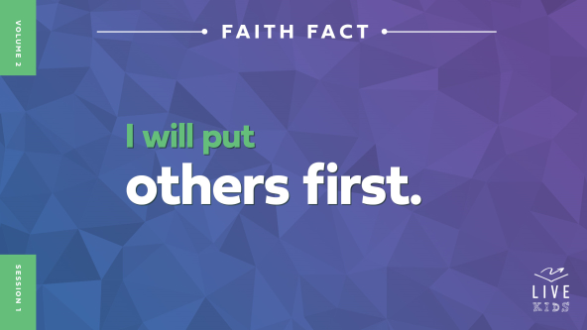

Let’s say that Faith Fact together to make it stick in our mind and heart. Point to your neighbor, and let’s say it together! **I will put others first.** Now point to your other neighbor and say it again. **I will put others first.** Well done!

**Game**

**Freeze Tag**

It’s time for a game! How many of you have played tag before? *(Group response)* Great! In normal tag, you just watch out for yourself. But today we’re talking about putting others first, so let’s play freeze tag!

In freeze tag, you risk everything to keep whoever is It from freezing everyone in the room. If the person who is It tags you, then you’re frozen in place until someone unfreezes you by giving you a tap on the arm or shoulder. Let’s play!

• *Consider limiting the freeze tag rounds to 1–2 minutes before changing who is It.*

• *If you have a large group, consider having more than one person at a time be It.*

• *If you don’t have a large space for kids to run without safety concerns, adjust the game to your environment. Instead of running, you might have kids walk quickly, walk backwards, crawl, etc.*

Great job, everyone! I saw you putting others first. You know what’s cool? When you risked your safety to unfreeze someone, you were actually giving yourself an advantage for later in the game. Whoever you unfroze would be able to help if *you* were frozen.

We’re going to learn today that putting others first makes us different in a way that pleases Jesus. Let’s say the Faith Fact together as a reminder. **I will put others first.**

**Worship**

Jesus was the perfect example of how to put others first. In fact, He gave His life for us. He loves us so much that He died on the Cross for our sins so we could be with Him forever someday! Let’s thank Him for putting us first as we worship Him together by singing.

• *Lead the kids in singing one or two praise songs. See suggestions at the beginning of the session.*

**Bible Lesson**

Thanks for worshipping with me! When we worship Jesus, we remember how amazing He has been and is to us. He loves us so much that He put us first and died on the Cross for our sins. Because Jesus did that for me, it makes me want to put others first too! Remember our Faith Fact? **I will put others first.** Let’s pray and then find out what Jesus meant when He taught about putting others first.

**Prayer**

|  |
| --- |
| *Dear Jesus, thank You that we can learn more about You today. Thank You for putting us first and dying for us. Help us be ready to find out how You want us to put others first too. In Your name we pray. Amen.* |

**Video Intro**

Before we dive into the Bible story, let’s watch this video.

• *Play* ***Bible Lesson Video****.*

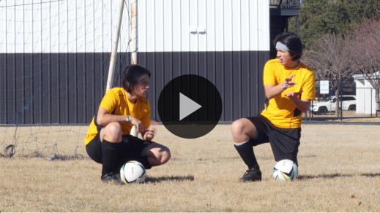

**Bible Story**

**Party Guests Discover the Best Seat**

Have any of you ever been in a situation like Dash was in? Maybe you know someone like Zeke who always wants to be the most important person in the room. Sometimes people want to take credit even when they don’t deserve it. But Jesus helps us know what to do when that happens.

**Teaching Time**

|  |
| --- |
| ***You Will Need***  *• Lunch box*  *• Variety of wrapped snacks to share with the group*  ***Getting Ready***  *• Fill the lunch box with the wrapped snacks.* |

In our Bible story, a Pharisee leader invited Jesus to his home for dinner. It was a big deal in those days to sit in the seat of honor near the host of the dinner. *Host* is just a word for the person who invited others to their dinner party. Everyone wanted the seat by the host because it meant they were important.

Do you think people were right or wrong to want to sit in the important seat? Raise your hand if you think it was right. *(Group response)* Raise your hand if you think it was wrong. *(Group response)*

I think that either one of those could be true, because it depends on the person’s reason for wanting the seat. It’s not always wrong to want something, like sitting in the special chair at a party. But if you want to sit there because you think you’re better than everyone else, then that’s a problem. Remember our Faith Fact? Let’s say it together. **I will put others first.** Let’s see what Jesus has to say about all of this.

Grab your Bible or pull up a Bible app on your device. Turn to [Luke 14:1](https://ref.ly/logosref/Bible.Lk14.1), [7–15](https://ref.ly/logosref/Bible.Lk14.7-15).

• *In order to keep Large Group time moving along, we recommend that the leader reads the Scripture portions aloud.*

• *Optional: Remind the kids to mark this place with a bookmark, so they can read it on their own at home.*

**1. Jesus was humble.**

• *Show the* ***Teaching Point 1 Slide.***

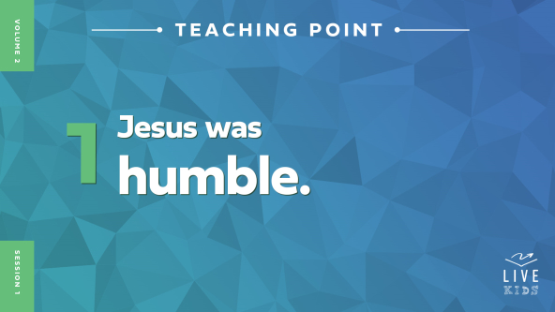

• *Read* [*Luke 14:1*](https://ref.ly/logosref/Bible.Lk14.1)*,* [*7*](https://ref.ly/logosref/Bible.Lk14.7)*.*

Jesus and some other people were invited to dinner by a Pharisee, a religious leader. Some people in that time didn’t understand how God wanted them to live. They didn’t trust Jesus or believe He was God’s Son. So they watched Him closely to see what He did.

At the Pharisee’s house, Jesus saw many people trying to get the best seat at the table. Do you think you’d want the best seat in the room if you were there? *(Group response)* I mean, it would be pretty cool to be the guest of honor, right?

Before we hear the advice Jesus gave, I have a question: How many of you have seen kids argue about who should be the line leader at school? *(Group response)* That’s pretty much what was going on at the Pharisee’s dinner table.

Who was the most important person who ever lived? *(Allow responses.)* You’re right! Jesus is the most important Person ever. Then doesn’t it make sense that Jesus, the Son of God, should have the best seat at the table? *(Group response)*

It totally makes sense! But even though Jesus was the most important Person, He didn’t fight for the seat of honor. Jesus was humble, which means He wasn’t proud or pushy.

**2. Jesus wants us to be humble.**

• *Show the* ***Teaching Point 2 Slide.***

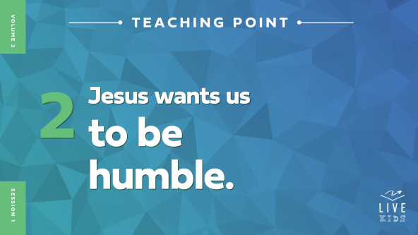

• *Read* [*Luke 14:8–11*](https://ref.ly/logosref/Bible.Lk14.8-11)*.*

Wait a second! What seat did Jesus tell everyone to take? *(Allow responses.)* Jesus told the people at the dinner to pick the worst seat at the table. If you do that, the one hosting the dinner might give you a better seat. Do you think the people at the Pharisee’s house liked what Jesus said? *(Group response)* Probably not! Being honored in front of everyone was a big deal. Jesus’ words would have been really hard to follow.

Jesus said it’s better to be humble first, and then you might be exalted. Does anyone know what *exalted* means? *(Allow responses.)* It means you’re raised higher because people honor and respect you. Jesus was trying to show everyone that it’s always better to be humble instead of proud.

When you’re at school, most kids would say the best place in the line is either the very front or the very back. The next best spots are as close as you can get to the front or back. The worst spot might be somewhere in the middle.

Imagine that your teacher tells your class to line up, and everyone is pushing and fighting for the best spots. But you calmly take your place in the middle of the line. Then after everyone lines up, your teacher calls for you to be the line leader! It might not always happen, but this time, your teacher saw that you were being humble instead of pushy and honored you for it. What are some other ways we can be humble? Let’s see what else Jesus said.

**3. Jesus put others first, and we can too.**

• *Show the* ***Teaching Point 3 Slide.***

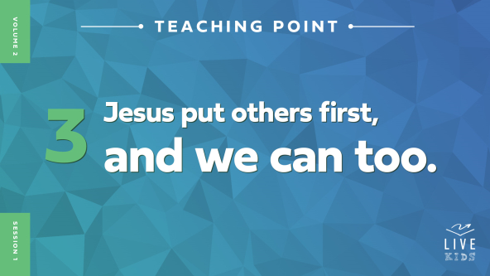

• *Read* [*Luke 14:12–15*](https://ref.ly/logosref/Bible.Lk14.12-15)*.*

Wow! Jesus was pretty clear to the dinner host. Jesus told him to not invite anyone who could pay him back. Instead, the host should invite people he knew couldn’t return the favor.

Now some of this could be kind of confusing. You might be thinking, *“Did Jesus really say I shouldn’t invite my family to dinner?”* No, Jesus was explaining that showing kindness to people who can’t pay you back is the sort of thing God rewards. Jesus really wants us to put those first who can’t repay us.

Imagine you’re at school again, and it’s lunchtime. *(Take out the lunch box filled with snacks.)* You open your lunch box and find the best snacks in there. Tell me what snack you’d like to find in your lunch box. *(Allow responses.)* Here’s what I have. *(Hold up and name what’s in the lunch box.)* If I listen to what Jesus said about being humble, what should I do with these snacks? *(Allow responses.)*

Jesus would want me to put someone else first. How could I do that? *(Allow responses.)* I could put someone else first by giving them my favorite snack. That would be humble, thoughtful, and kind. Should I listen to Jesus’ words right now? *(Group response)*

• *Share the snacks with everyone in the room.*

Remember our Faith Fact today: **I will put others first**. Putting others first is what Jesus told us to do, and He showed us how to do it too. When we choose to be humble, we’ll think about other people before ourself. That makes us different in the best way possible—just like Jesus!

**Prayer and Response**

*Consider playing a worship song softly in the background while kids pray.*

Sometimes it can be hard to figure out how to truly put others first. How can we serve people if it means we don’t get what we want? But Jesus showed us how. And the Holy Spirit can help us follow what Jesus said.

Today, we’re going to pray and ask Jesus two questions: Who do You want me to put first? And how can I do it this week? As we pray, I want you to ask Jesus these questions, either out loud or in your mind. Then listen carefully to the thoughts you have. That is often how the Holy Spirit speaks to us!

Maybe you’ll think about someone in your family who needs your help. Maybe you’ll remember a kid in your class who doesn’t have many friends. Maybe you’ll think about a special gift you can give to someone. Let’s pray.

• *Be silent for a couple of minutes while kids pray.*

• *Optional: Have the kids share with each other what they feel Jesus wants them to do.*

**Prayer**

*Optional: Have the kids repeat phrases of the prayer after you.*

|  |
| --- |
| *Dear Jesus, thank You for teaching us how to put others first. Please show us how we can be different by putting other people ahead of ourself. We trust You’ll give us what we need as we put others first. In Your name we pray. Amen.* |

**Faith Verse**

Our Faith Verse is all about being different from the world in the very best way possible—by letting God change the way we think and the way we treat others! Let’s learn it together.

• *Play* ***Faith Verse Video****.*

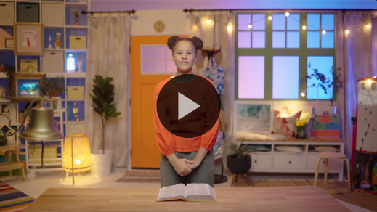

[Romans 12:2](https://ref.ly/logosref/Bible.Ro12.2) (NLT)

Don’t copy the behavior and customs of this world, but let God transform you into a new person by changing the way you think.

This verse helps us remember our job and God’s job. Our job is to choose to be humble and let God change us. Then His job is to make us new and different. He will even change the way we think. Isn’t that awesome?

**Faith Fact**

Now, let’s review our Faith Fact again. **I will put others first.**

• *Show the* ***Faith Fact Slide****.*



Let’s say that Faith Fact together. When you say “I,” point to yourself. Then when you say “others,” point to someone else. Ready? **I will put others first.** Let’s do that again. **I will put others first.** Great job!

• *Dismiss kids to Small Group time or to go home if your group time ends here.*

**Small Group**

**30 Minutes**

*This section can be done in conjunction with the large group or on its own if you do small groups with your kids. During Small Group time, the goal is to connect the kids with the Word of God and to each other. All activities are led by the small group leader.*

**Group Connection**

**Musical Chairs**

|  |
| --- |
| ***You Will Need***  *• Chairs, one per kid*  *• Smartphone, computer, radio, etc. for playing music*  ***Getting Ready***  *• Put the chairs in a circle.* |

In our Bible story, Jesus watched people compete for the best seat at the dinner table. We’re going to pretend we’re the people at that dinner *before* Jesus explained how to put others first. So that means we all want the best seat in the house!

Let’s play Musical Chairs. We’ll start with one more person than there are spots at the dinner table. You’ll walk in a circle around the dinner seats. I’ll be the host. When I say, “Dinner’s ready!” you’ll hurry to get a seat. Whoever doesn’t get a seat in that round is out. But before they leave the circle, they need to share a fun fact about themselves with the group.

• *After each round, remove one more chair until only one chair remains.*

**Bible Lesson Recap**

• *If small group activities are not immediately following large group time, you may want to read the Bible story passage before the discussion.*

|  |
| --- |
| ***You Will Need***  *• Bibles for kids in the group to share*  *No prep needed for this activity.* |

**Bible Story Review: Party Guests Discover the Best Seat** [**Luke 14:1**](https://ref.ly/logosref/Bible.Lk14.1)**,** [**7–15**](https://ref.ly/logosref/Bible.Lk14.7-15)

What was the most interesting thing about our Bible story today? *(Allow responses.)* Those are great answers!

Let’s do a quick review. Jesus went to a special dinner. Everyone tried to get the best seats because they wanted to be the most important. But Jesus told everyone to pick the worst seat instead. Then He told the host to invite people to dinner who could never pay him back if he wanted to be rewarded by God. Jesus was teaching everyone how important it is to be humble and put others first.

• *Optional: Give each kid a Bible and read the Bible story together.*

**Group Discussion**

*Feel free to use all or just a few questions as a jumping-off place for good discussion. Questions marked with * are designed for more conversation. Adjust the questions based on the age or maturity of your group. Typically, older kids will be able to dive a little deeper than younger ones.*

**Questions**

What were people competing for at the dinner?

Jesus was the most important Person in the Pharisee’s house. Why didn’t He take the best seat?

Do you think what Jesus said changed people’s minds about finding a place to sit at dinner? Why or why not?

Do you think the host listened to what Jesus told him about who to invite to dinner next time? Why or why not?

How is Jesus the best example of putting others first?

Why do you think Jesus wants us to put other first?

* How does putting others first show that we are different from the world?

* How can we be humble and not proud? Why can this be hard?

Does being humble mean that you think badly about yourself? Why or why not?

* What is a situation where someone who put others first could be recognized or honored for it?

**Live It**

|  |
| --- |
| ***You Will Need***  *• Sticky notes, one sheet per kid*  *• Pencils or pens, one per kid*  *No prep needed for this activity.* |

**Faith Fact**

Our Faith Fact today is **I will put others first.** Jesus wants us to be humble and think about others’ needs before our own. He knows it can be hard to do, and He wants to help us. When we put others first, we show them Jesus’ love in a very special way. Earlier we prayed about who we could put first. Now, let’s write their name down now so we don’t forget!

• *Give each kid a sticky note and pencil or pen.*

• *Have them write down the name of the person God wants them to put first this week.*

**Challenge**

Take this note home and put it where you’ll see it every day. Then tell your parents about who you’re planning to put first like Jesus told us to do. Remember to look for ways to put that person first!

**Prayer**

*Finish group discussion by sharing prayer requests and praise reports. Keep track of your small group’s prayer requests and review them each time you meet.*

• *Have kids share and pray for each other’s prayer requests.*

|  |
| --- |
| *Dear Jesus, thank You for being humble and putting us first, even when we didn’t deserve it. Help us to see how we can put others first, so they can see the special, different love You put in our heart. In Your name we pray. Amen.* |

**Faith Verse Review**

|  |
| --- |
| ***You Will Need***  *• Ball*  *• Optional: Smartphone to time activity*  *No prep is needed for this activity.* |

When God changes the way we think, our actions change too. Then our new way of living honors Him and shows His love to the people around us. Let’s practice our Faith Verse now.



[Romans 12:2](https://ref.ly/logosref/Bible.Ro12.2) (NLT)

Don’t copy the behavior and customs of this world, but let God transform you into a new person by changing the way you think.

**Faith Verse Fun**

**Toss Across**

All right, now it’s time to put our knowledge of the Faith Verse to the test. We’ll sit in a circle on the floor, and one person will hold this ball. We’ll each take turns saying one word at a time from our Faith Verse. When you’ve said the word that comes next, pass the ball to another person in the circle, and they’ll say the next word. We’ll keep doing this until we say the whole verse. If you get stuck, you can call on the rest of us for help. Once we get the verse down, we’ll time ourselves to see how fast we can pass the ball and say the Faith Verse!

• *Recite the verse one word at a time, having kids pass the ball around or across the circle after each word.*

• *Once the group has the verse down, challenge them to race against the clock.*

Great job, everyone! Memorizing this Faith Verse will help transform your mind, which will help you put others first.

**Activity Page**

**Journal Page**

|  |
| --- |
| ***You Will Need***  *•* ***Small Group Activity Page****, one per kid*  *• Pencils or pens, one per kid*  *• Crayons or markers*  ***Getting Ready***  *• Print copies of the* ***Small Group Activity Page****, one per kid.* |

Our Faith Fact today is **I will put others first.** We already talked about *who* we will put first this week. Now we’re going to figure out *how* we’re going put them first!

• *Hand out a copy of the* ***Small Group******Activity Page****, a pencil, and crayons to each kid.*

Let’s write some ideas or draw a picture of how you plan to put someone else first this week. Share at least two ways. This could be a way you’ve helped someone in the past, or it could be something totally new. Let’s be creative together!

• *Give kids time to complete the page.*

What great ideas! I’m excited to hear all about how you put others first this week.

**Dismissal**

Remember, Jesus wants us to be different from the rest of the world. When we follow Him and do what He did, we are different in the best way possible! Let’s pray.

**Prayer**

|  |
| --- |
| *Dear Jesus, please help us to put others first, even when it’s difficult. Help us to be bold, selfless, and kind. Help us to humble ourself and to treat other people with the love You showed to us. Amen.* |

**Faith Fact Recap**

• *Show the* ***Faith Fact Slide****.*



Jesus doesn’t want just me or someone else to put others first. He wants *you* to stand out in amazing ways for Him too! Let’s say the Faith Fact together one more time. **I will put others first.** I’m so glad you came today. I can’t wait to see you next time.

• *Send home the* ***Small Group Activity*** *Page and the sticky note with a person’s name on it.*

• *Remind parents that there are* ***Family Devotions*** *available on the app to do with their kid.*

• *Tell everyone the date and time for the next session.*